Name – Aarsh Bhavsar

Student ID – 202101474 Lab - 2

1. (Tutorial Exercise) Determine the Nyquist sampling rate and the Nyquist sampling interval for the following signals.
   * x(t) = sinc(100πt) + 3 sinc2 (60πt)
   * x(t) = 1 + cos(2000πt) + sin(4000πt).
   * x(t) = sinc(100πt) + 3 sinc^2 (60πt)

Here, the expression can be expanded as x(t) = sin(100πt)/100πt + 3*(1-cos(120πt))/2/(60πt)^2, so, the maximum frequency component here is 120π Hz. So, f = 120π/2π = 60Hz which implies Nyquist rate = 2*60Hz = 120Hz and Nyquist interval = 1/120s = 0.008333333333s.

* + x(t) = 1 + cos(2000πt) + sin(4000πt). x(t) = 1 + cos(2000πt) + sin(4000πt).

Here, the expression has maximum frequency component as 4000π Hz. So, f = 4000π/2π Hz = 2000Hz and Nyquist rate = 2*2000Hz = 4000Hz. The Nyquist interval = 1/4000s = 0.00025s.

1. MATLAB Exercise

# Experiment 1

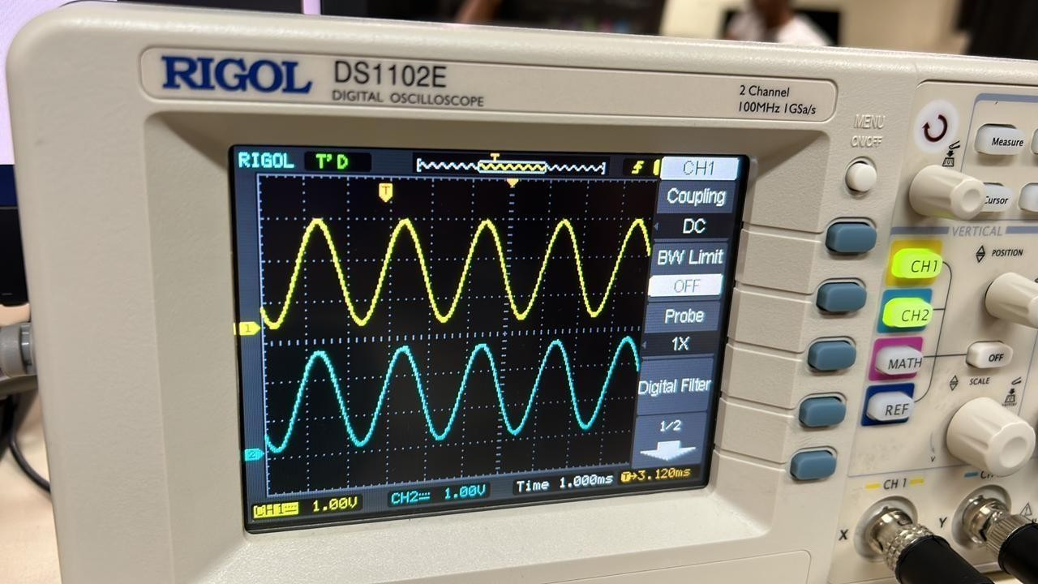3.

1.1

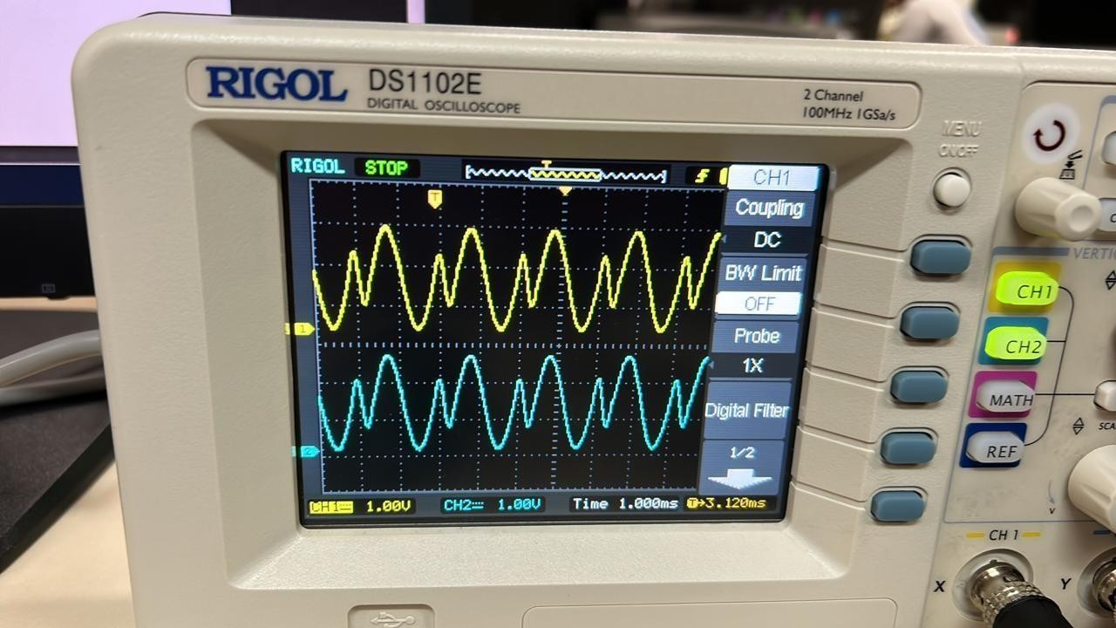

1.2

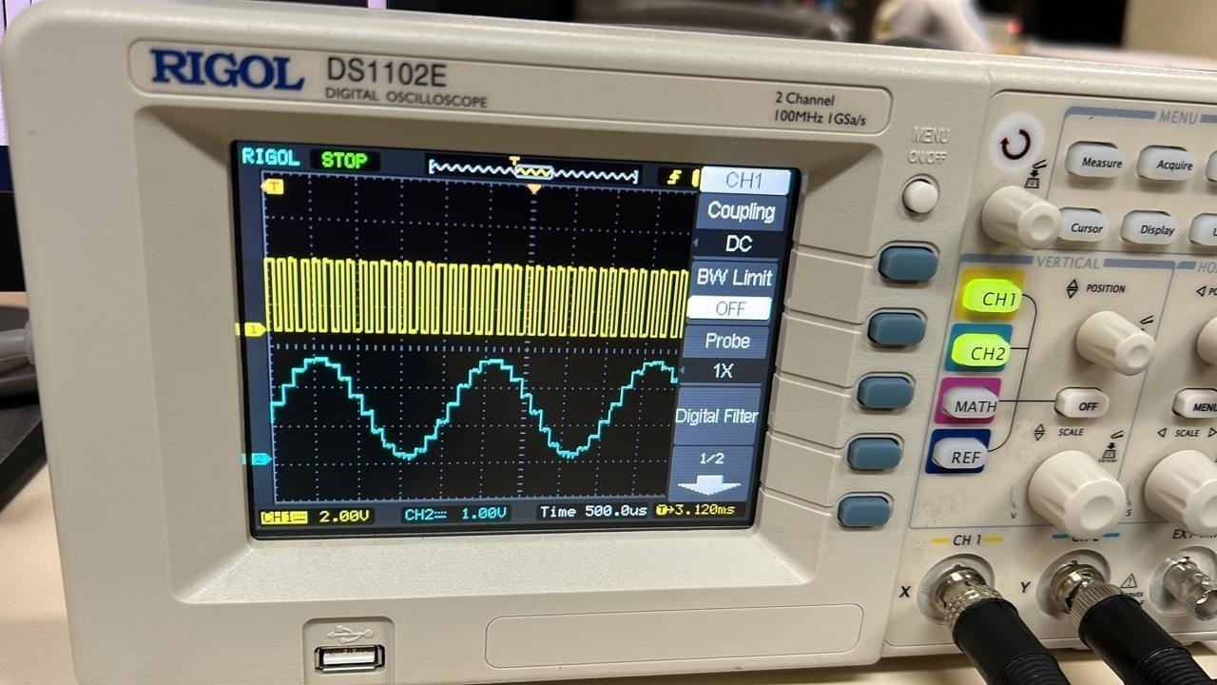

1.3

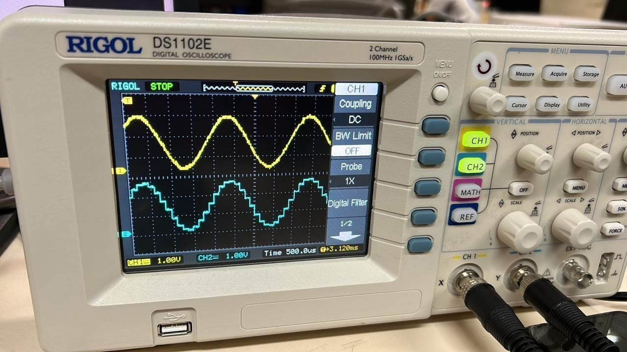

1.4

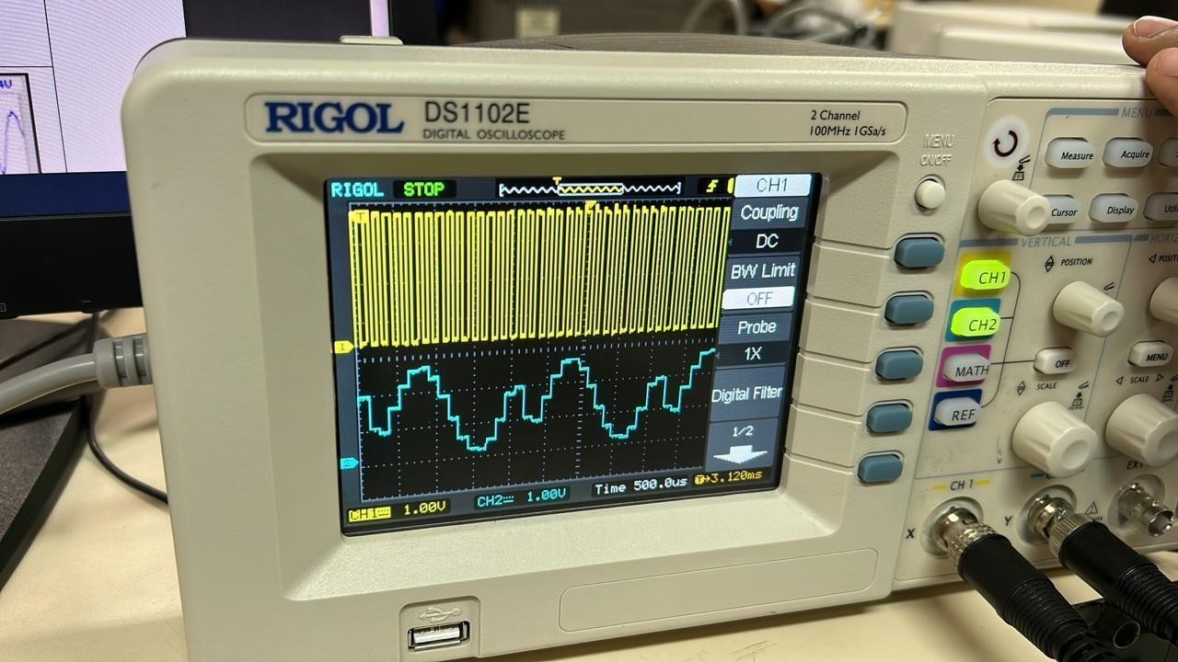

1.5

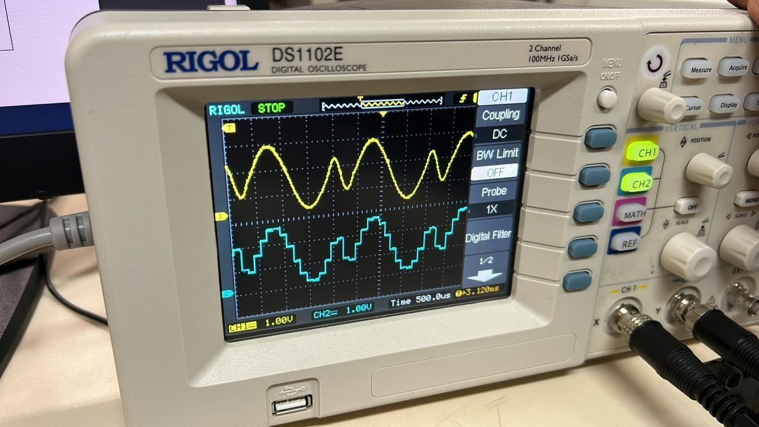

1.6

# Experiment 2

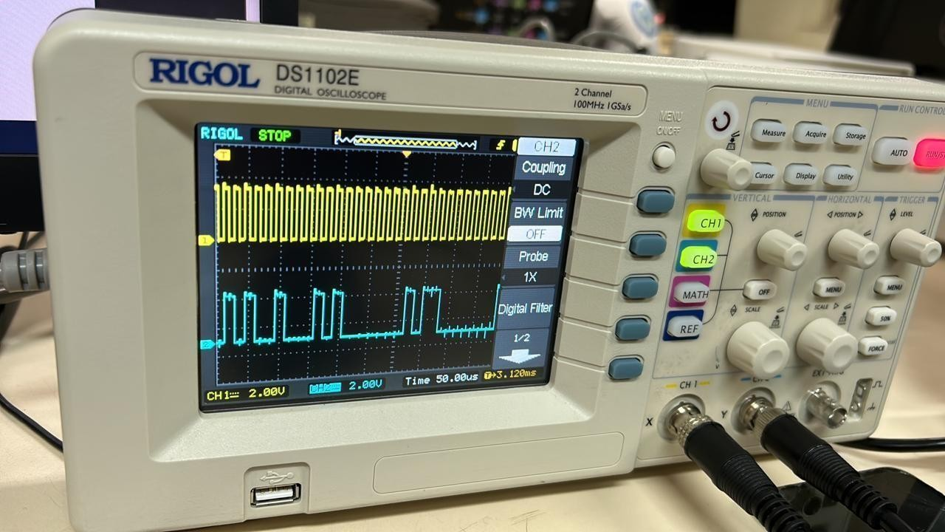

2.1

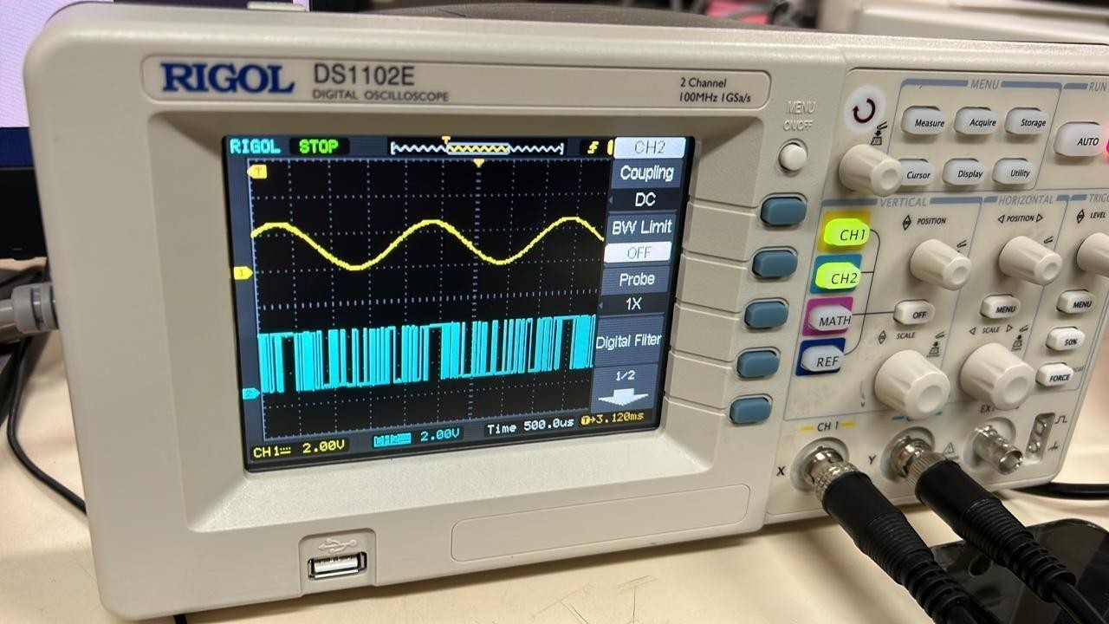

2.2

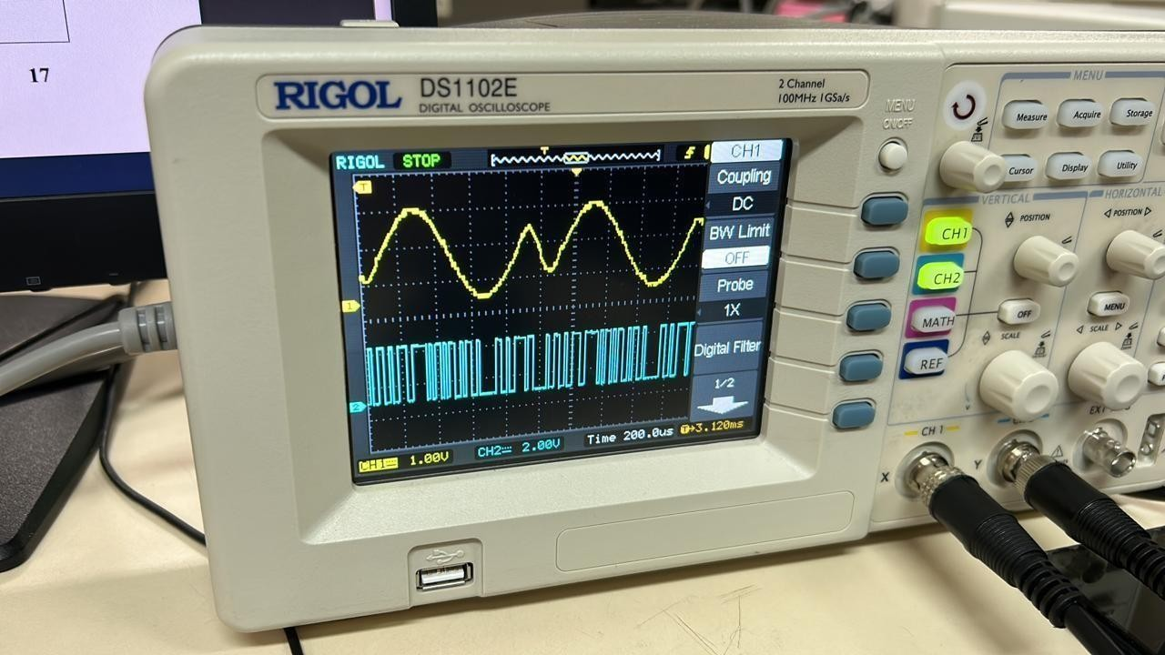

2.3

# Experiment 3

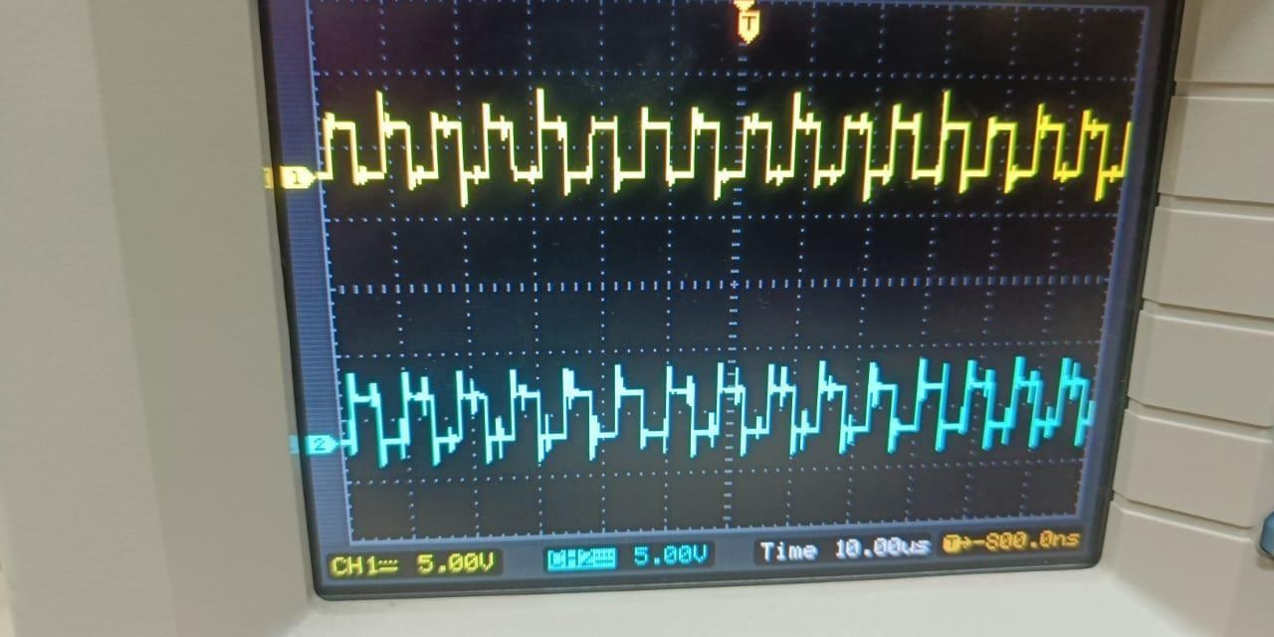

3.1

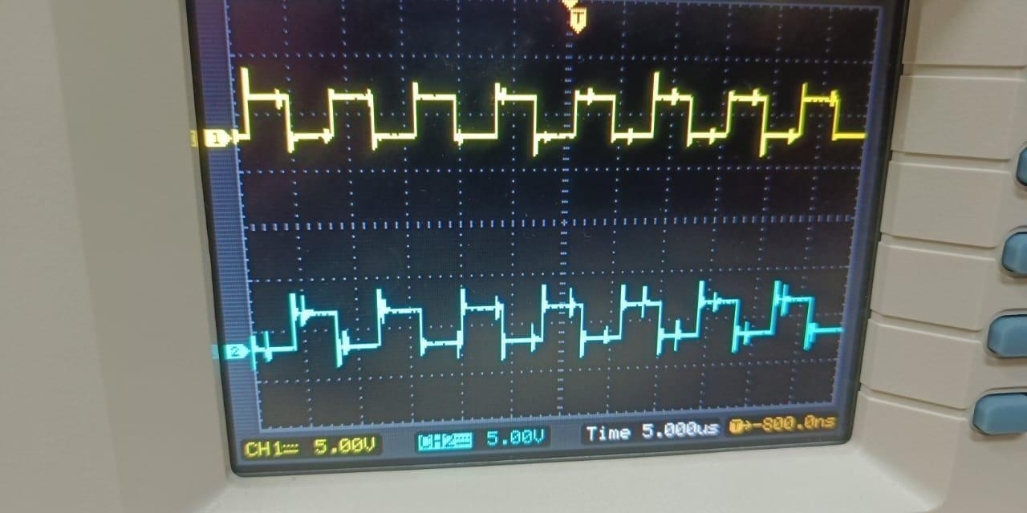

3.2

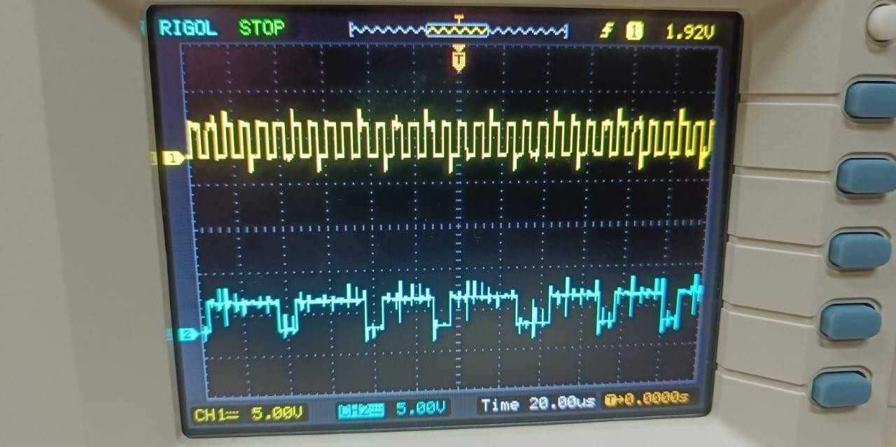

3.3

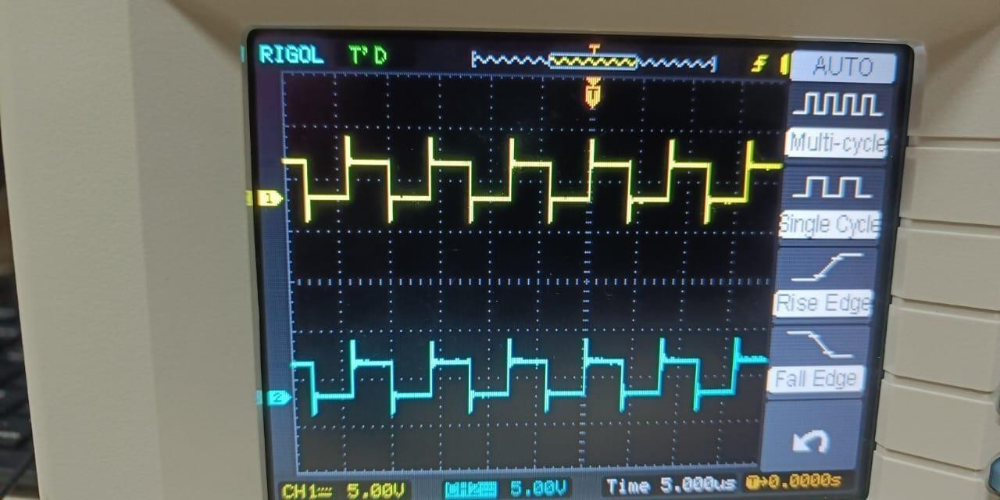

3.4

# Experiment 4

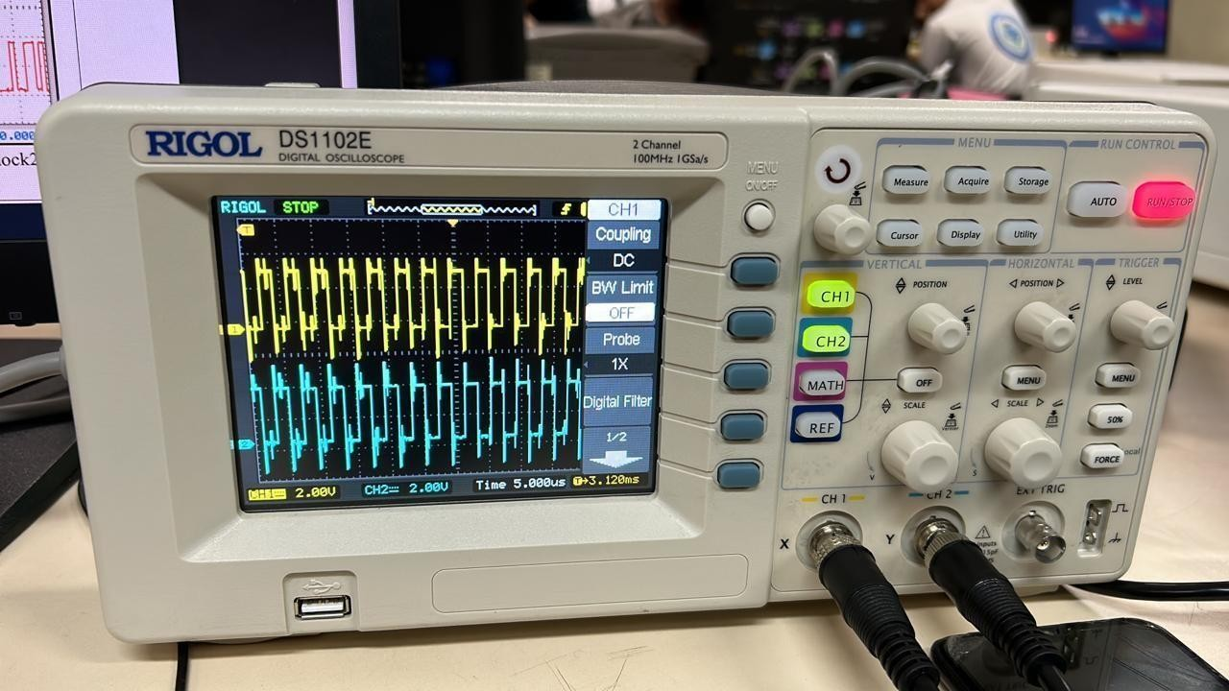

4.1

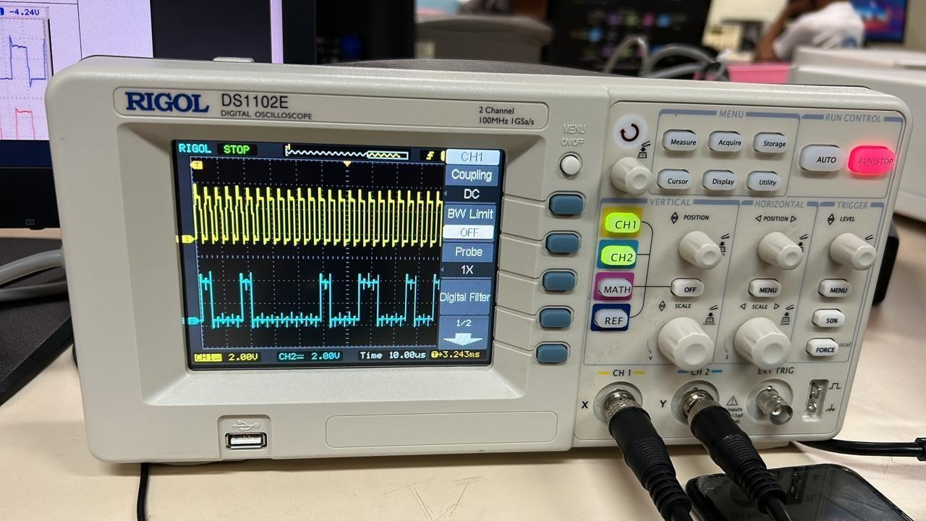

4.2

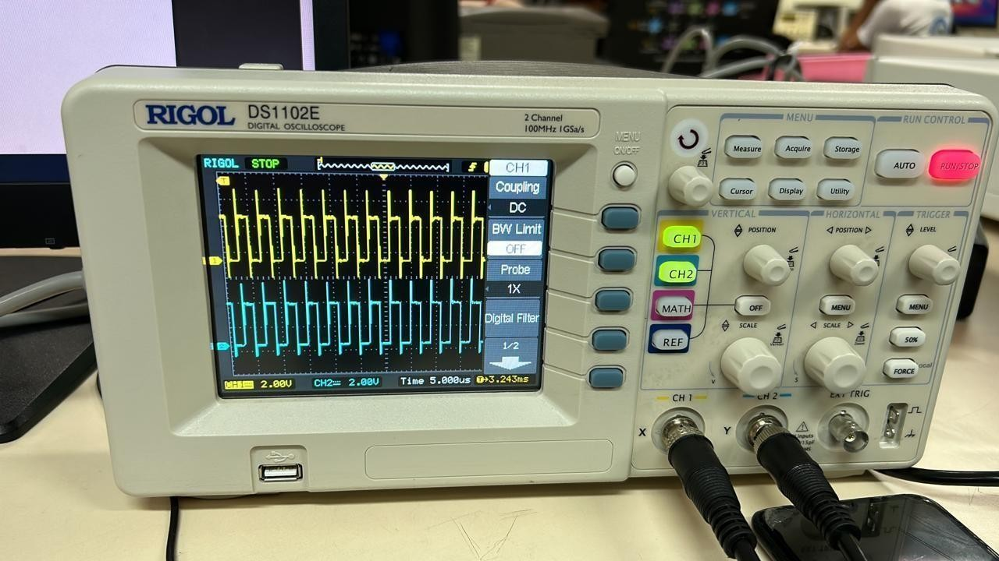

4.3

# Experiment 5

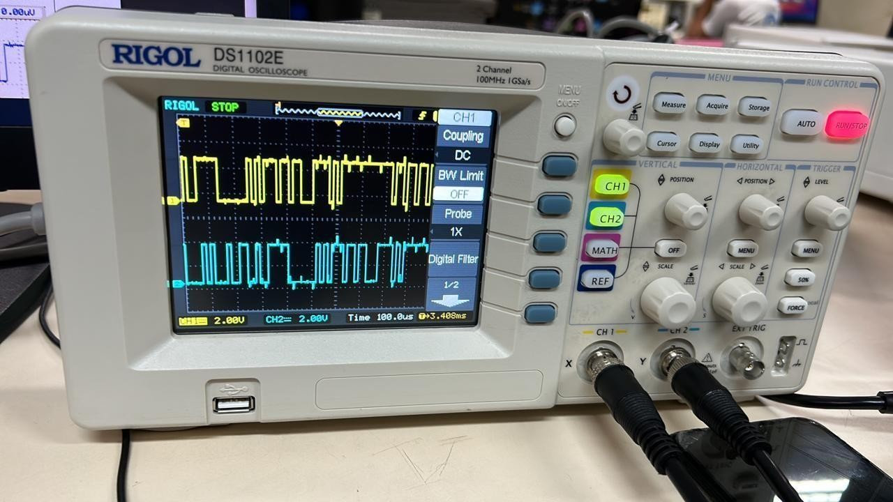

5.1

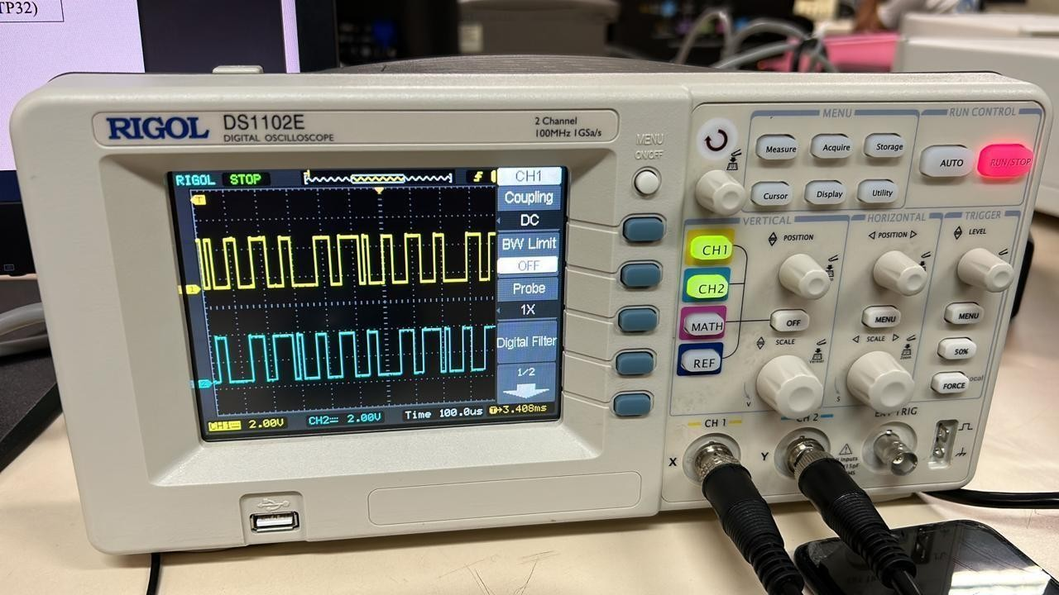

5.2

# Experiment 6

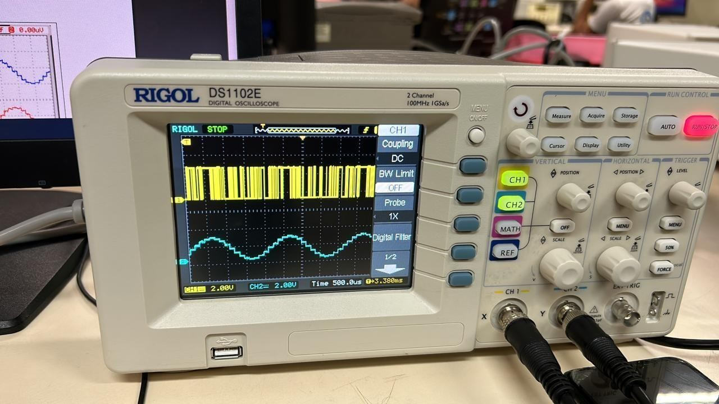

6.1

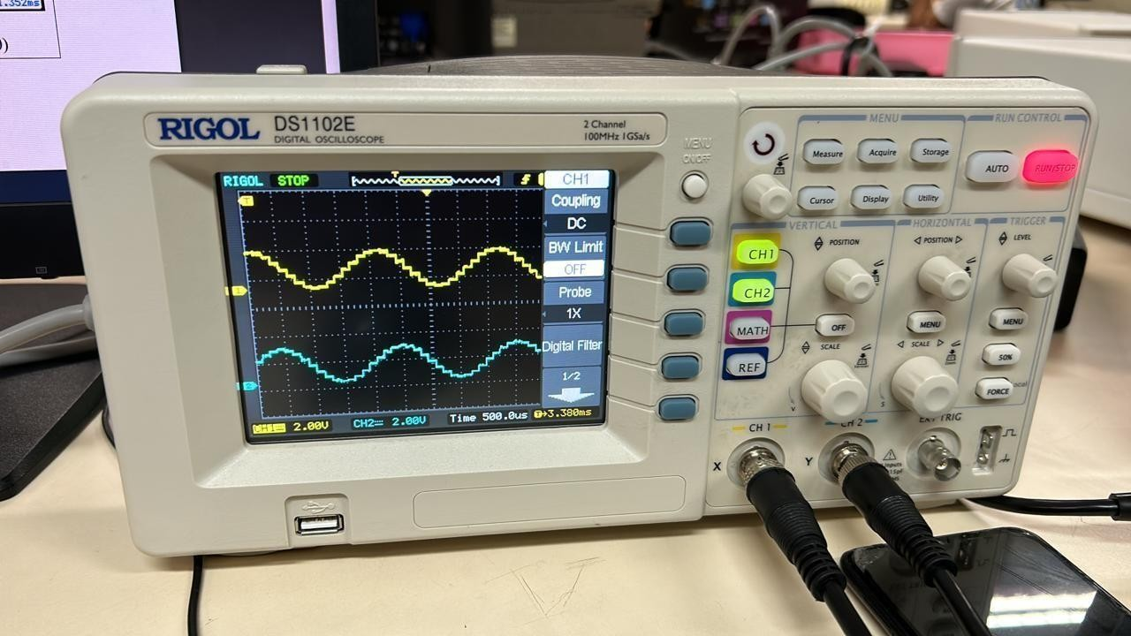

6.2

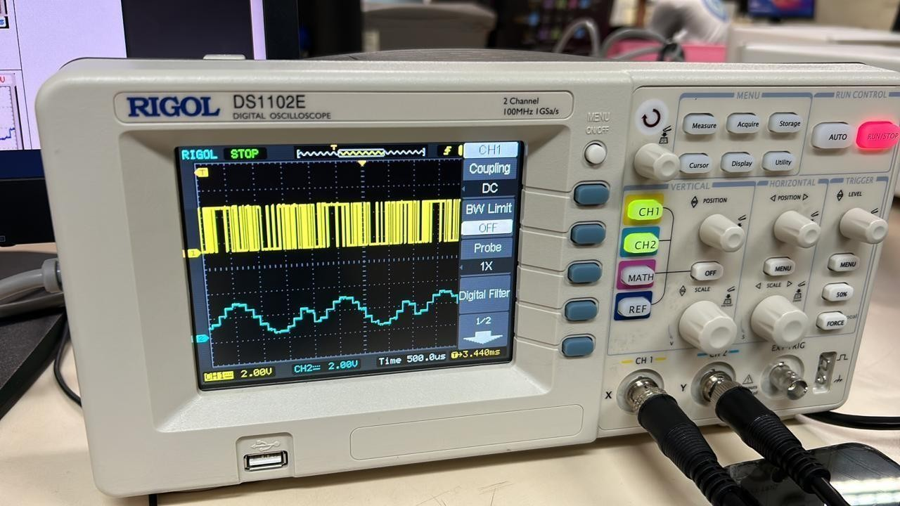

6.3

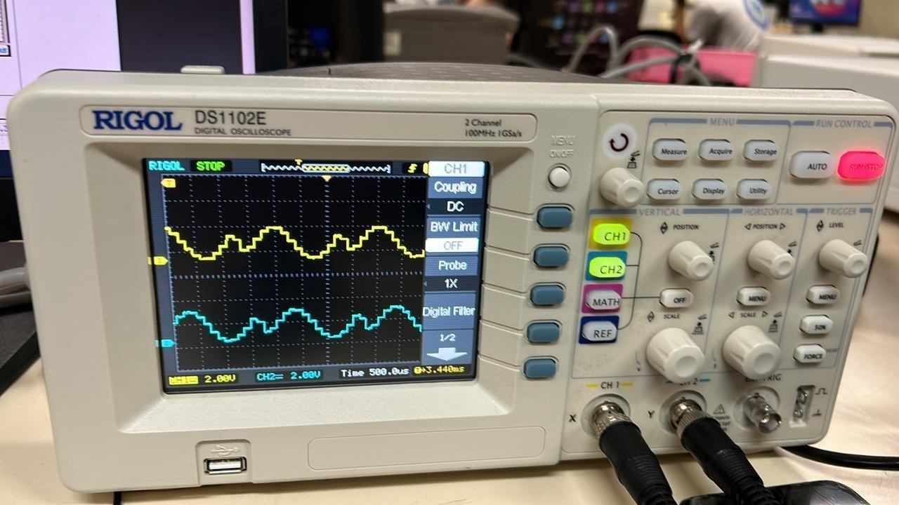

6.4

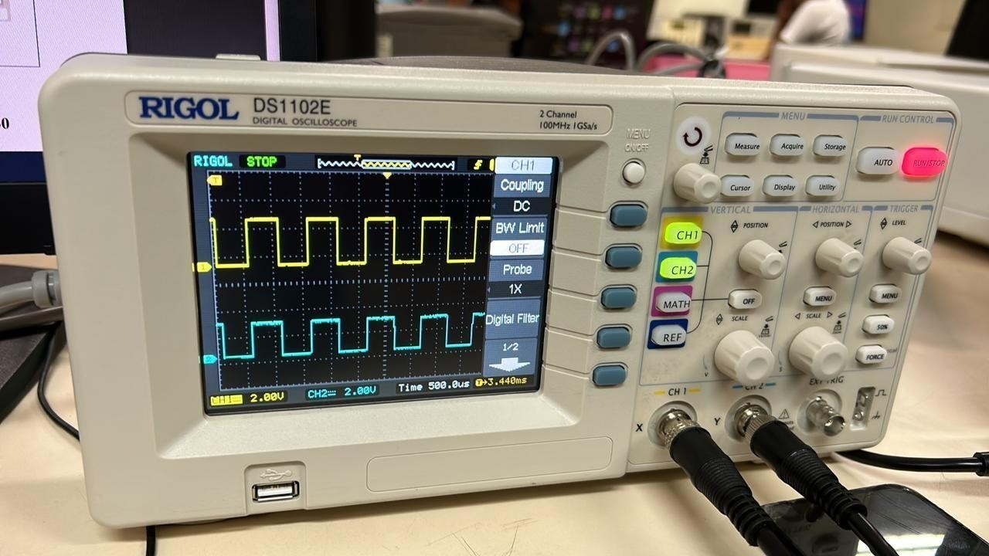

6.5

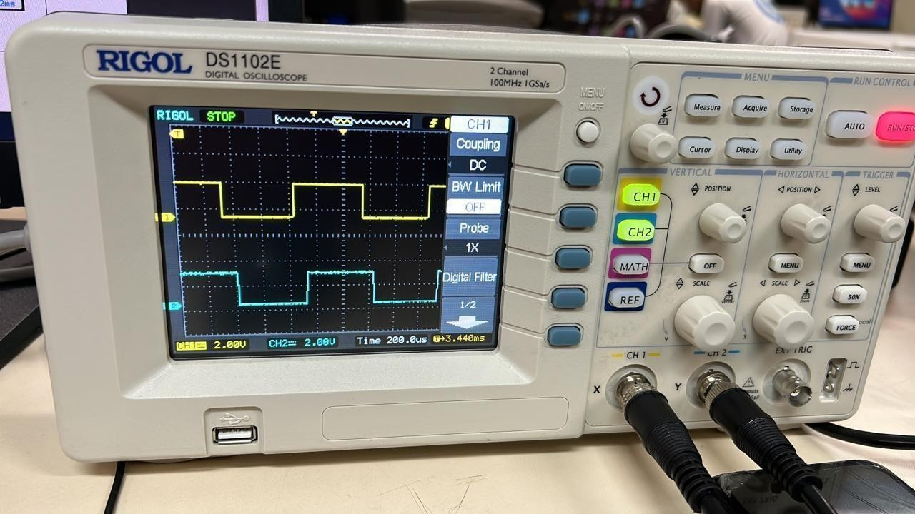

6.6

# Experiment 7

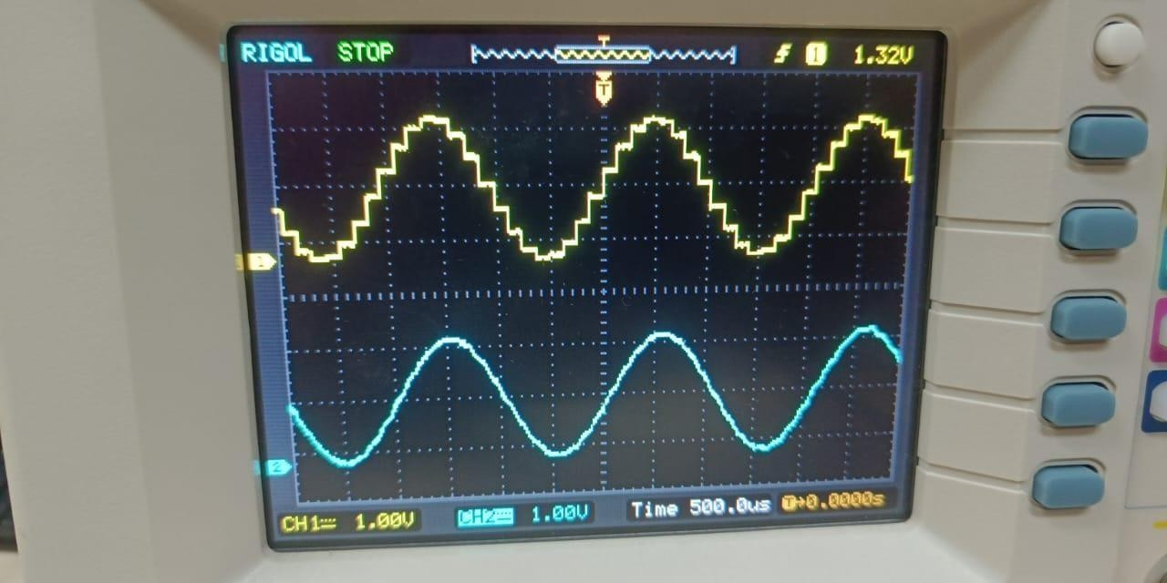

7.1

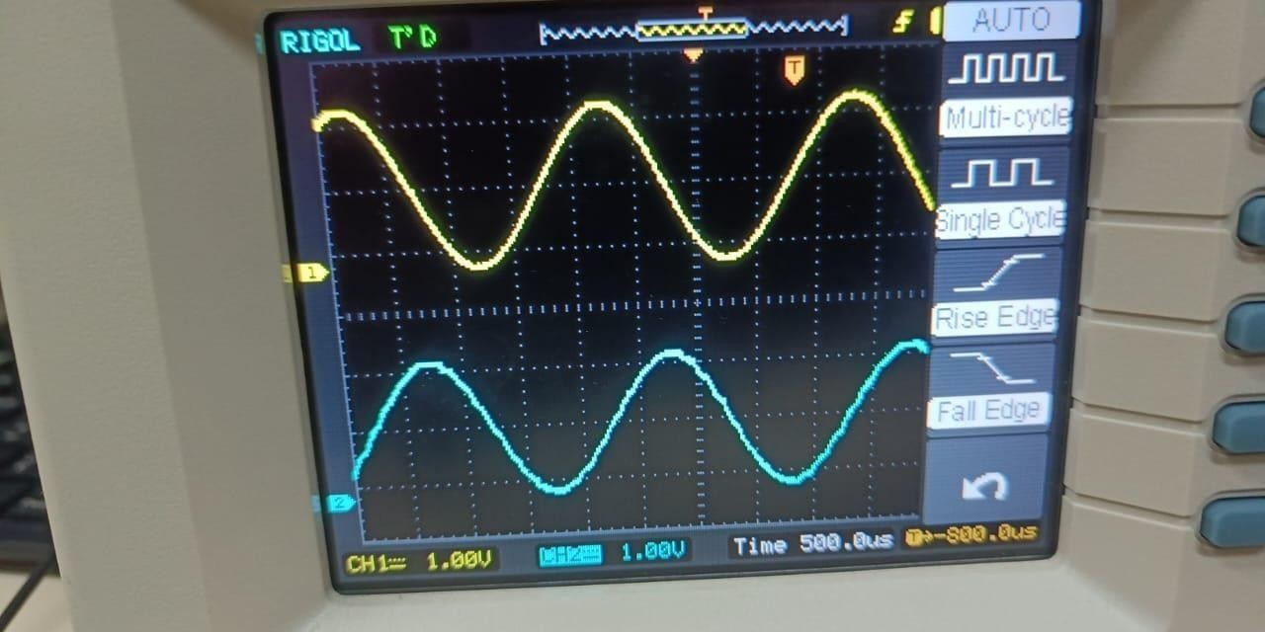

7.2

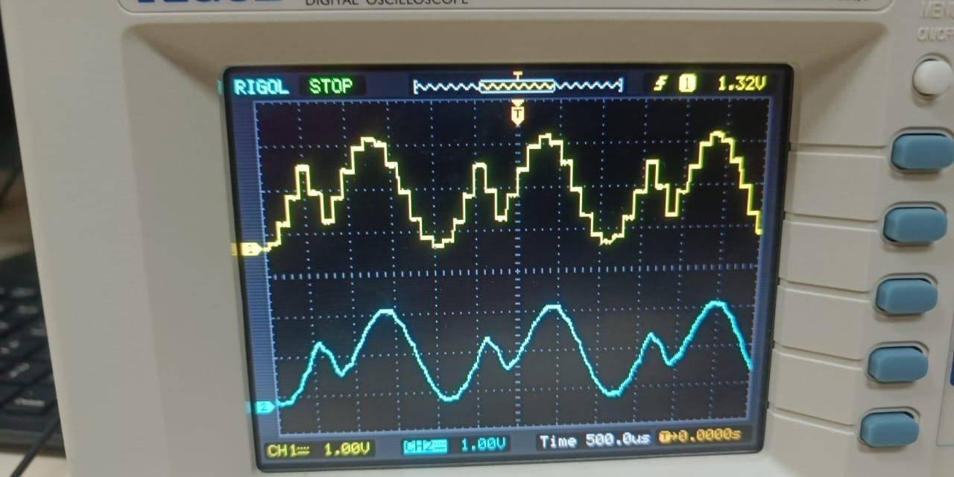

7.3

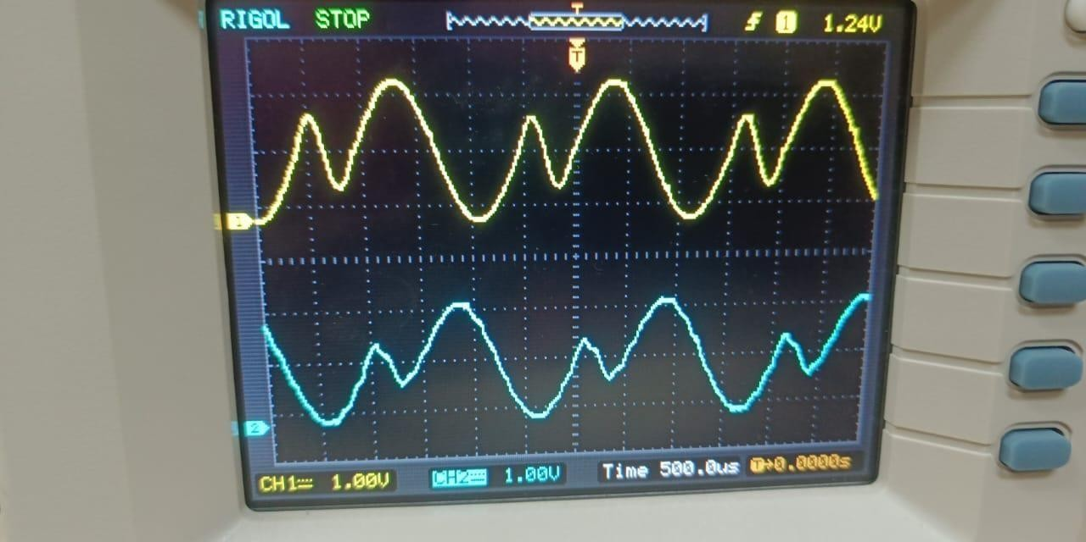

7.4

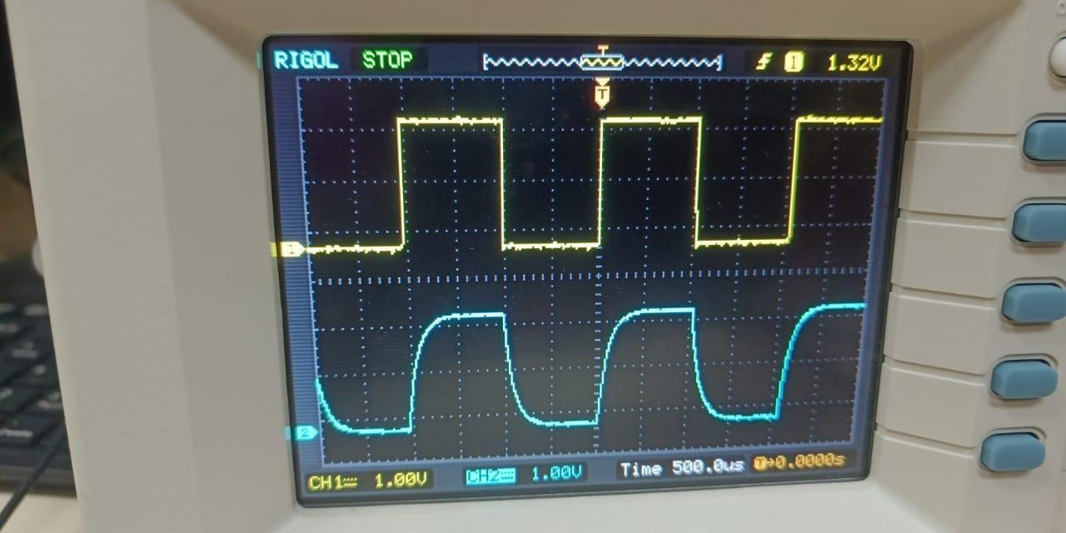

7.5

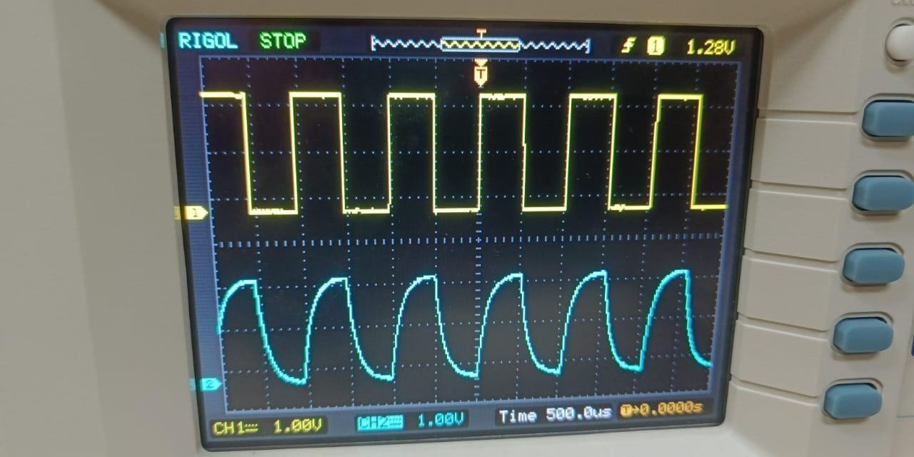

7.6

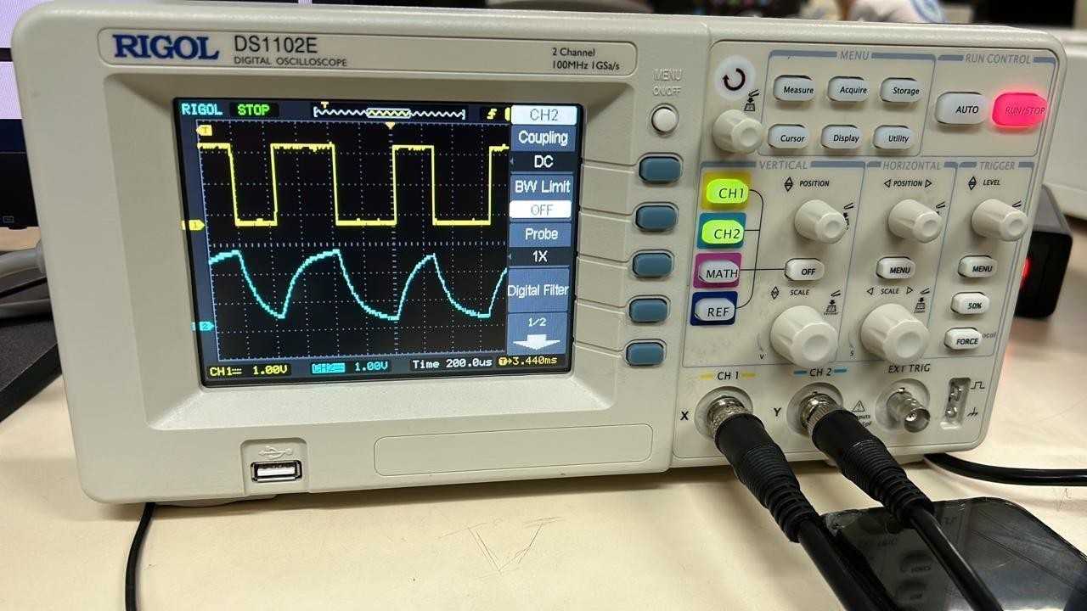

7.7

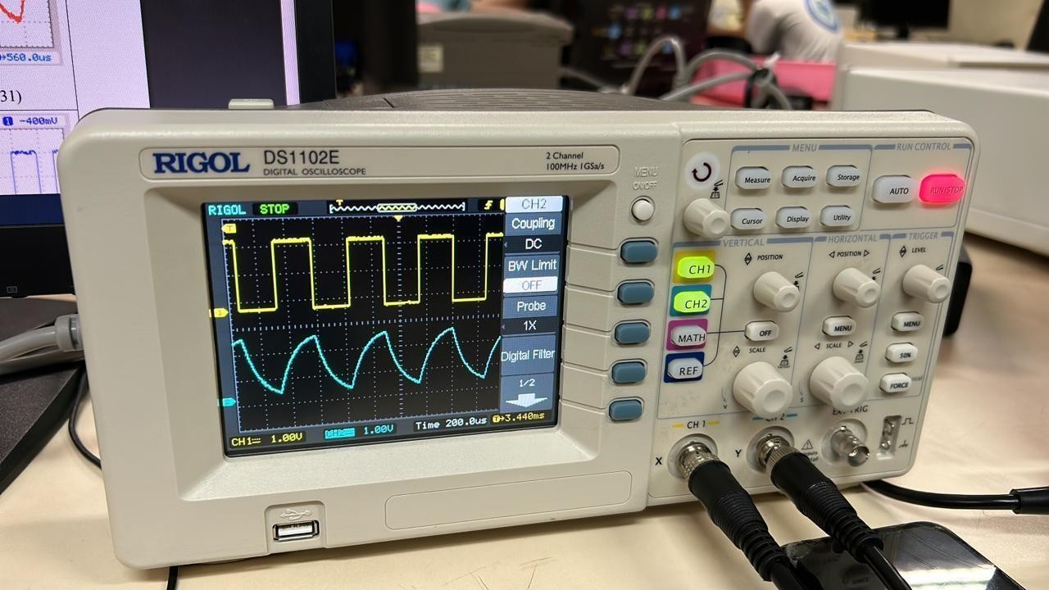

7.8

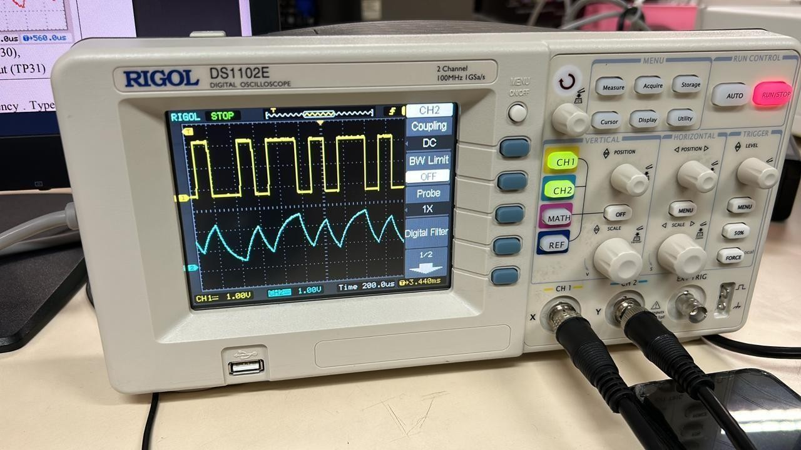

7.9

clear;clf; td= 0.002 ; t = [0:td:2];

%original sampling rate 500 Hz

% t ime interval of 2 seconds xsig=cos (10*pi*t) +cos(16*pi*t); Lsig=length(xsig);

ts=0.02;

Nfactor=ts / td;

%new sampl ing rate = 50Hz .

% s end the signal through a 16-leve l uni form quant i z er

[ s_out , sq_out , sqh_out , Delta , SQNR ] = sampandquant (xsig,16,td,ts) ;

% rece ive 3 signal s:

% 1. sampled signal s_out

% 2. sampled and quant ized signal sq_out

% 3. sampled , quant i zed , and zero- order hold signal sqh_out

%

% calculate the Fouri er transforms Lfft= 2.^ceil(log2(Lsig)+1) ; Fmax= 1/ (2*td ) ;

Faxis=linspace(-Fmax ,Fmax , Lfft ) ; Xsig=fftshift ( fft ( xsig , Lfft ) ); S_out=fftshift ( fft ( s_out ,Lfft ) );

% Examples of sampl ing and recons truc tion us ing

% a) ideal impulse train through LPF

% b) flat top pul se recons truc tion through LPF

% plot the original signal and the sample signals in t ime

% and frequency domain figure (1) ;

subplot (311) ; sfig1a=plot(t,xsig , ' k ');

hold on ; sfig1b=plot(t,s_out(1:Lsig) ,' b ' ) ; hold off ;

%set(sfig1a , 'LineWidth' ,2) ; set(sfig1b , 'LineWidth' , 2); xlabel( ' time ( sec ) ');

title( ' Signal {\it g}({ \it t } ) and its uniform samples ' ) ; subplot(312); sfig1c=plot(Faxis , abs(Xsig));

xlabel( ' frequency ( Hz ) '); axis([ - 300 300 0 600])

set(sfig1c , 'LineWidth' , 1 ) ; title ( ' Spectrum of {\it g} ( {\it t } ) '); subplot(313) ; sfig1d=plot(Faxis , abs( S_out ) );

xlabel ( ' frequency (Hz ) ');

axis ( [ - 300 300 0 600 /Nfactor ] )

set(sfig1c , 'LineWidth' , 1 ); title ( ' Spectrum of {\it g }_T ( {\it t } ) ');

1

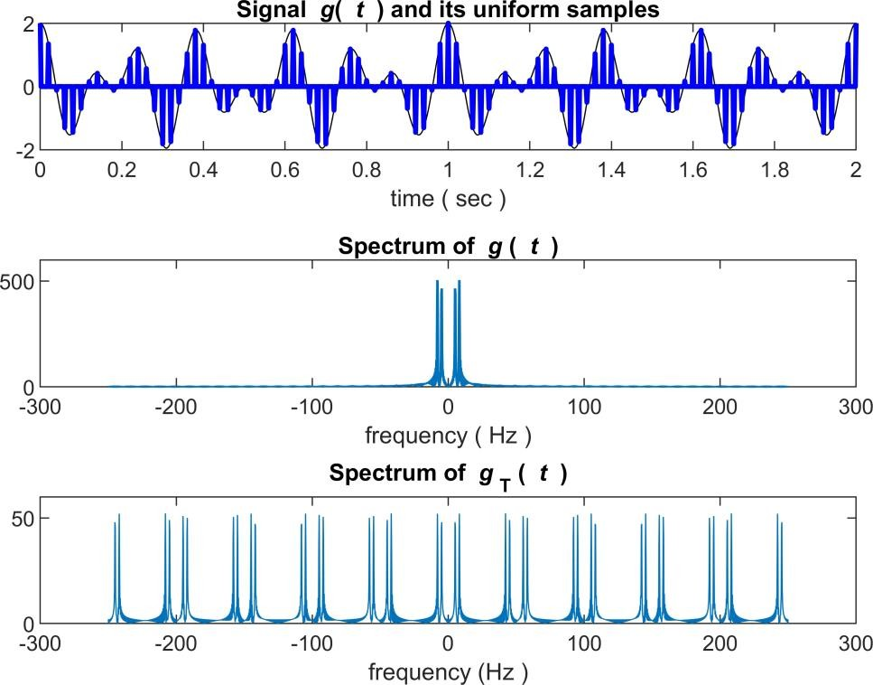

% calculate the recons tructed signal from ideal sampl ing and

% ideal LPF

% Maximum LPF bandwidth equal s to BW= f l oor ( ( Lfft /Nfactor ) / 2 ) ; BW=100 ; %Bandwidth is no larger than 100Hz .

H_lpf= zeros(1, Lfft); H_lpf(Lfft/2-BW : Lfft/2+BW-1) = 1 ; %ideal LPF S_recv=Nfactor* S_out .* H_lpf ; % ideal fil tering s_recv=real(ifft(fftshift(S_recv))) ; % recons tructed £ -domain s_recv= s_recv(1:Lsig) ; % reconstructed t-domain

% plot the ideal ly reconstructed signal in t ime

% and frequency domain figure(2)

subplot (211) ; sfig2a=plot(Faxis , abs(S_recv) ); xlabel ( ' frequency ( Hz ) ');

axis ( [ -300 300 0 600] );

title ( ' Spectrum of ideal filtering ( reconstruction ) ');

subplot(212 ) ; sfig2b=plot(t,xsig , ' k- . ' , t , s_recv(1 : Lsig) , ' b '); legend( ' original signal ', ' reconstructed signal ');

xlabel( ' time ( sec ) ');

title( ' original signal versus ideally reconstructed signal '); set( sfig2b, 'LineWidth' ,2) ;

2

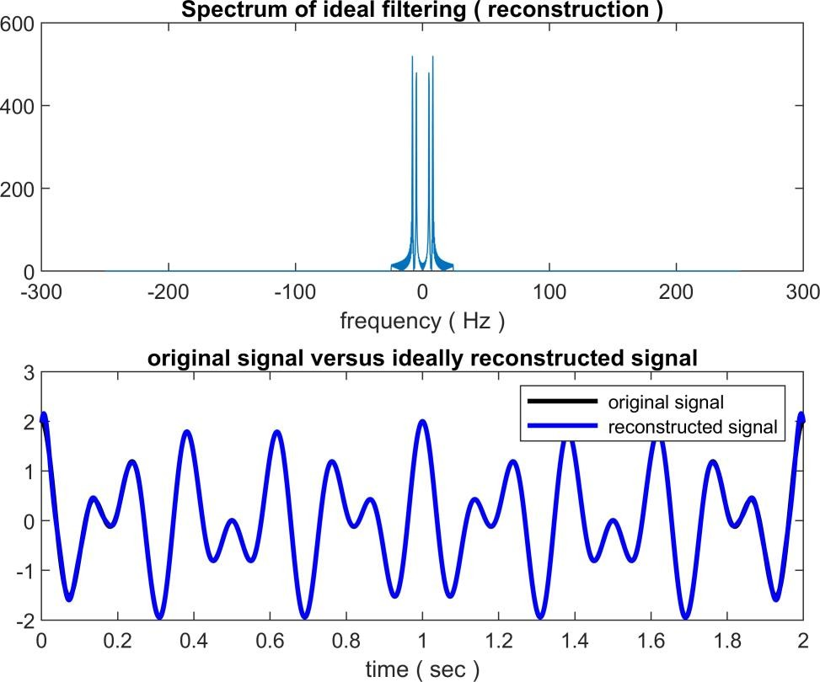

% non-ideal reconstruction ZOH=ones(1, Nfactor ) ;

s_ni =kron( downsample( s_out , Nfactor ),ZOH) ; S_ni = fftshift( fft( s_ni , Lfft ) );

S_recv2 =S_ni .*H_lpf; % ideal filtering

s_recv2 =real(ifft( fftshift( S_recv2 ))); % reconstructed f-domain s_recv2 =s_recv2 (1:Lsig) ; % reconstructed t-domain

% plot the ideally reconstructed signal in time

% and frequency domain figure (3)

subplot(211); sfig3a=plot(t,xsig , 'b' , t , s_ni (1:Lsig) , ' b '); xlabel( ' time ( s ec ) ');

title ( ' original signal versus flat- top reconstruction '); subplot(212); sfig3b=plot(t,xsig , t , s_recv2 (1:Lsig) ) ; legend( ' original signal ', ' LPF reconstruction ');

xlabel ( ' time ( sec ) ');

set( sfig3a, 'LineWidth' ,2) ; set(sfig3b , 'LineWidth' ,2) ; title ( ' original and flat- top reconstruction after LPF ' );

3

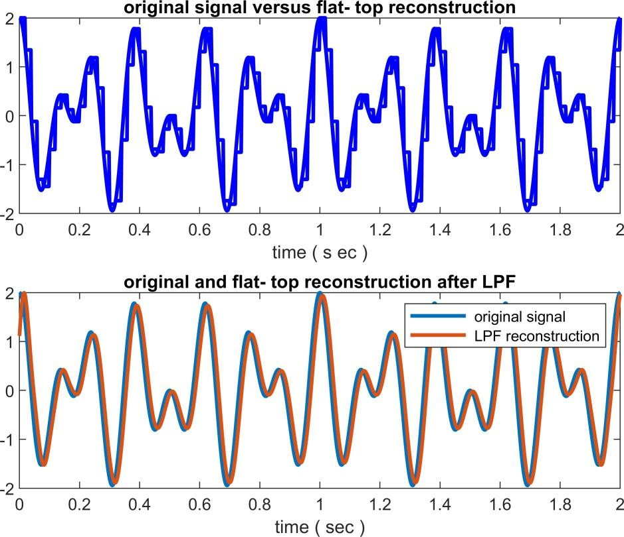

)

function [ q_out ,Delta , SQNR]=uniquan( sig_in , L )

% Usage

% [ q out , Delta , SQNR] =uniquan ( s ig_in , L )

% L number of uni form quant i zation l evels

% sig_in - input signal vec tor

% Func tion outputs:

% q out - quant i zed output

% Del ta - quantization interval

% SQNR

sig_pmax=max( sig_in ) ;

%actual signal to quant i zation noise ratio

% f inding the pos i t ive peak

sig_nmax=min( sig_in ) ; % finding the negative peak Delta= ( sig_pmax- sig_nmax ) /L; % quantization interval

q_level=sig_nmax+Delta/2 : Delta : sig_pmax-Delta / 2 ; % de f ine Q-levels L_sig=length( sig_in ) ; % find signal l ength

sigp=(sig_in- sig_nmax ) / Delta+1/2 ; % convert into 1/2 to L+ l/2 range qindex=round( sigp ) ; % round to 1, 2, ... L levels

qindex=min ( qindex , L ) ; % eleminate L+l as a rare possibility q_out =q_level(qindex) ; % use index vec tor to generate output SQNR=20.*log10(norm(sig_in)/norm( sig_in-q_out )); %actual SQNR value end

% ( sampandquant .m)

function [ s_out , sq_out , sqh_out , Delta , SQNR] = sampandquant ( sig_in , L , td , ts

% Usage

4

% [ s_out , sq_out , sqh_out , Delta , SQNR] =sampandquant ( s ig_in , L , td , f s )

% L number of uni form quantization l evels

% sig_in - input signal vec tor

% td original signal s ampl ing period of sig_in

% ts new sampl ing period

% NOTE : td* fs must be a pos itive integer ;

% Func tion output s:

%s out - sampled output

%6. 9 MATLAB Exercises 315

%

%

%

%sq_out - sample-and-quantized output

%sqh_out - sample , quantize , and ho ld output

%

%

%Delta - quant ization interval

%SQNR - ac tual signal to quanti zation noise ratio if ( rem(ts/td , 1 ) ==0 )

nfac=round( ts/td ) ; p_zoh=ones(1,nfac ) ; s_out=downsample( sig_in , nfac ) ;

[ sq_out , Delta , SQNR] =uniquan( s_out , L ) ; s_out=upsample( s_out,nfac ) ; sqh_out=kron(sq_out ,p_zoh ) ;

sq_out=upsample( sq_out , nfac ); else

warning( 'Error ! ts / td is not an integer ! ');

s_out= [] ; sq_out= [] ; sqh_out= [] ; Delta= [] ; SQNR= [] ; end

end

5